Cliff Rodriguez
Using Stata Problem 3
Affiliations:
CU Denver

Abstract:

Cliff Rodriguez
2-12-2018

Style Guidelines
- Double space
- Equations
  - begin on a new line
  - centered on the page
  - numbered sequentially
  - describe important variables when introducing an equation
  - state whether or not standard errors are in parenthesis near the first equation
- Commands
  - List any special commands used in an appendix
- Graphs and tables
  - May be in-text or at the end
- Paper citations
  - Author (Year)

Introduction
- State basic objective
- Explain why study is important
- Review of literature and what has already been done and how previous work can be improved upon
- Present leading table or graph is paradox or paper topic is introduced well with the visual aid
- Summarize findings
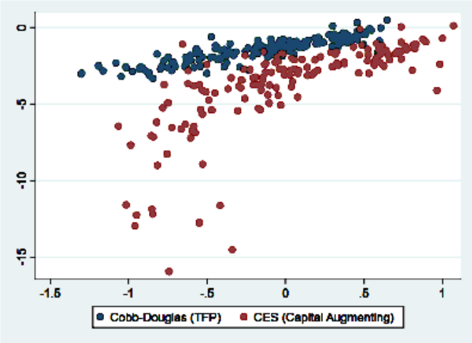

Conceptual (or theoretical) Framework
- Describe approach to answering questions being asked
  - Intuitive and conceptual problems are included in discussion
- Discussion on what factors should be controlled for and what factors are included and why

Econometric Models and Estimation Methods
- Key equations estimated and presented in the results section
  - Fix ideas about what they key explanatory variable is and what other factors will be controlled for
  - Including equations with error terms allows for a discussion on whether OLS is a suitable method
    - Discuss whether OLS is suitable for this method
- Make distinction between model and if estimation method and what is being used
  - Do not discuss what variables have been omitted, this goes in the results section
  - After specifying model/s discuss estimation methods
    - Discuss any assumptions made is obtaining an estimable econometric model

Data
- Describe data used in empirical analysis
- Include enough information so analysis could be repeated by the reader
- Discuss data sources
- Discuss units of each variable
  - May be presented in a table format
- Table of summary statistics may be included
  - Present means for binary variables
  - Computing the average growth rate can be interesting
- State the number of observations
  - Identify years for time series datasets and descriptions of any special periods (wars, recessions, etc.)
  - For pooled cross section or panel set data be sure to report how many cross-sectional units are included for each year

Results
- Include estimates of any models formulated in the models section
  - Start with simple analysis
- Results may be presented in equation form with standard error in parenthesis below estimated coefficients
- For many explanatory variables, use a tabular form for presenting the equations
  - Make dependent and independent variables clearly indicated
  - Select units that make coefficients understandable
  - Do not use scientific notation in tables
- Most papers will have at least one table that includes the R² value and the number of observations for each equation.
- The most important part is to discuss the interpretation and strength of empirical results
  - Do coefficients have the expected sign?
  - Are they statistically significant?
  - Explain why anything counterintuitive might be happening
  - Describe magnitude of coefficients on the major explanatory variables
    - For variables central to the study signs, magnitudes, and statistical significance should be discussed in detail
    - Distinguish between economic and statistical significance
    - Dropping a group of variables to simplify a model can be justified via an F-Test
    - Comment on any important differences if multiple methods were used

Conclusion
- Summarize what you have learned
  - Can present the magnitude of a coefficient that was of particular interest
  - Discuss any caveats to the conclusion drawn
  - Suggest direction for further research

Appendix
- Commands Used:
- Table Data – Unfiltered

